***Task i) : -*** *Dual boot or install a VM with Linux OS. Refer to a YouTube video for the same.*

* Installed **Oracle VM VirtualBox**: Oracle VM VirtualBox is cross-platform virtualization software. It allows users to extend their existing computer to run multiple operating systems including Microsoft Windows, Mac OS X, Linux, and Oracle Solaris, at the same time.
* Creating a Virtual Machine using Virtual Box: -
* Click Machine → New → Enter Name (of machine) → Select Machine Folder → Type as Linux → Version (of our choice say “Ubuntu 64bit”) → Next
* Selected Hardware: Base Memory 8192MB(8GB) and Processors 16 CPUs
* Hard Disk options: Created a Virtual Hard disk of 100GB
* Click Finish and machine is created
* Click Start and the machine boots
* Installing Ubuntu: -
* Select startup disk: Selected the .iso file of Ubuntu predownloaded from official website.
* Click Install Ubuntu → move forward with default options.
* Virtual Machine created with Linux OS(Ubuntu).

***Task ii) : -*** *Create an account on GitHub. Familiarize with Git and GitHub commands using videos.  Make a repository for writeups. Make a detailed write-up for each task completed.*

* GIT Commands: -

1. Configuring name and email address:

* **git config –global user.name “…”**
* **git config –global user.email “…”**

1. For empty git repository: **gitint**
2. To take the file to staging area: **git add <file_name.extension>**

* Add multiple files to staging area: **git add -A**

1. Status of the file created: **git status**
2. Create a new file: **touch <file_name.extension>**
3. Commit files: **git commit -m “…. your msg ….”**
4. To match file with last commit: **git checkout <file_name.extension>**

* Match multiple files with last commit: **git checkout -f**

1. Log/Record of all files committed: **git log**

* Filter o/p of git log: **git log -p -<no. of last commits we want to see>**

1. Compares working directory with staging area: **git diff**
2. Compares last commit with staging area: **git diff --staged**
3. Skip stagging area & directly commit: **git commit -a -m “…. your msg ….”**
4. List the files present: **ls**
5. Delete a file completely(from working tree): **git rm <file_name.extension>**

* File only removed from staging area: **git rm --cached <file_name.extension>**

***Task iii) : -*** *Complete the first 12 levels of Bandit and maintain write-ups*

* *Level 0: -*
* *Goal****:*** The goal of this level is for you to log into the game using SSH. The host to which you need to connect is **bandit.labs.overthewire.org**, on port 2220.
* *Code:* ssh [bandit0@bandit.labs.overthewire.org](mailto:bandit0@bandit.labs.overthewire.org) **-p 2220**
* We then enter the password which is given for level 0 moving on to level 1.
* *Inference:* **ssh** (SSH client) is a program for logging into a remote machine and for executing commands on a remote machine. It connects and logs into the specified *destination*, specified as [user@]hostname]
* *Level 0→1: -*
* *Goal****:*** The password for the next level is stored in a file called **readme** located in the home directory.
* *Used commands:*
* **ls -alps:** *Used to list all the files in the directory*
* **cat readme:** *Use to read the contents present in readme file*
* We then receive the password required for moving from level 0 *→* 1.
* *Level 1→2: -*
* *Goal****:*** The password for the next level is stored in a file called **-** located in the home directory
* *Used commands:*
* **ls -alps:** *Used to list all the files in the directory.*
* **cat ./- :** *Use to display the contents of the “–“ file name.*

* We then receive the password required for moving from level 1→ 2.
* *Level 2→3: -*
* *Goal****:*** The password for the next level is stored in a file called **spaces in this filename** located in the home directory
* *Used commands:*
* **ls -alps:** *Used to list all the files in the directory.*
* **cat spaces\ in\ this\ filename :** *Use to display the contents of the file whose name has spaces*

*in it.*

* We then receive the password required for moving from level 2→ 3.
* *Level 3→4: -*
* *Goal****:*** The password for the next level is stored in a hidden file in the **inhere** directory.
* *Used commands:*
* **ls -alps:** *Used to list all the files in the directory.*
* **cd inhere/ :** *Use to enter the inhere directory.*
* **ls -al:** *Used to list all the files(including hidden) in the inhere directory*
* **cat .hidden :** *Use to display the contents of the hidden file named ”.” in the inhere directory.*

* We then receive the password required for moving from level 3→ 4.
* *Level 4→5: -*
* *Goal****:*** The password for the next level is stored in the only human-readable file in the **inhere** directory.
* *Used commands:*
* **ls -alps:** *Used to list all the files in the directory.*
* **cd inhere/ :** *Use to enter the inhere directory.*
* **ls :** *Used to list all the files(excluding hidden) in the inhere directory.*
* **file ./* :** *Gives the data type of all the files present in the current directory.*
* **cat <file name> :** *By entering the file name of file whose type is ascii text we get the contents of the file which has human-readable password.*

* We then receive the password required for moving from level 4→ 5.
* *Level 5→6: -*
* *Goal****:*** The password for the next level is stored in a file somewhere under the **inhere** directory and has all of the following properties: i)Human Readable; ii)1033 bytes in size; iii)not executable.
* *Used commands:*
* **ls -alps:** *Used to list all the files in the directory.*
* **cd inhere/ :** *Use to enter the inhere directory.*
* **find -size 1033c -readable ! -executable :** *Gives the location and name of the file fulfilling the said properties.*
* **cat <file name> :** *We specify the path and file name received to get the password for next level.*

* We then receive the password required for moving from level 5→6.
* *Level 6→7: -*
* *Goal****:*** The password for the next level is stored somewhere on the server and has all of the following properties: i) owned by user bandit7; ii) owned by group bandit6; iii) 33 bytes in size.
* *Used commands:*
* **cd /:** *Jumps to the root directory as we need to search the entire Linux system.*
* **find -size 33c -user bandit7 -group bandit6 :** *Gives the location and name of the file fulfilling the said properties.*
* **cat <file name> :** *We specify the path and file name received to get the password for next level.*

* We then receive the password required for moving from level 6→7.
* *Level 7→8: -*
* *Goal****:*** The password for the next level is stored in the file **data.txt** next to the word **millionth.**
* *Used commands:*
* **ls -alps:** *Used to list all the files in the directory.*
* **strings data.txt | grep “millionth” :** *Gives the password located next to the word millionth in the file data.txt*

* We then receive the password required for moving from level 7→8.
* *Level 8→9: -*
* *Goal****:*** The password for the next level is stored in the file data.txt and is the only line of text that occurs only once.
* *Used commands:*
* **ls -alps:** *Used to list all the files in the directory.*
* **sort data.txt | uniq -c :** *Gives the lines in the text and how many times each of the lines is repeated.*

* We then receive the password required for moving from level 8→9 by choosing the line which occurs only once.
* *Level 9→10: -*
* *Goal****:*** The password for the next level is stored in the file data.txt in one of the few human-readable strings, preceded by several ‘=’ characters.
* *Used commands:*
* **ls -alps:** *Used to list all the files in the directory.*
* **strings data.txt | grep “=” :** *Gives all the strings located next to “=” in the file data.txt*

* We then receive the password required for moving from level 9→10 by analysing the results we get after running the above command as shown in the fig below: -

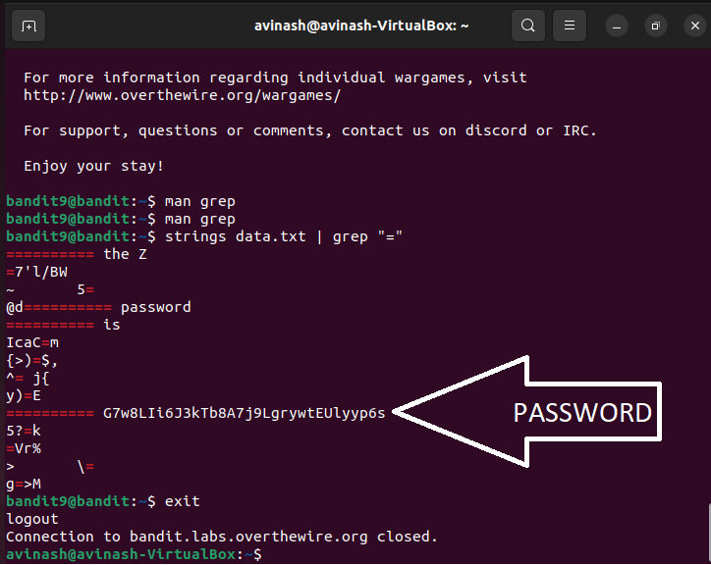

* *Level 10→11: -*
* *Goal****:*** The password for the next level is stored in the file data.txt, which contains base64 encoded data
* *Used commands:*
* **ls -alps:** *Used to list all the files in the directory.*
* **cat data.txt:** *Gives the contents of the file data.txt*
* **base64 -d data.txt:** *decodes the base64 data and gives the standard output*

* We then receive the password required for moving from level 10→11
* *Level 11→12: -*
* *Goal****:*** The password for the next level is stored in the file data.txt, where all lowercase (a-z) and uppercase (A-Z) letters have been rotated by 13 positions
* *Used commands:*
* **ls -alps:** *Used to list all the files in the directory.*
* **cat data.txt | tr a-zA-Z n-za-mN-ZA-M:** *tr a-zA-Z n-za-mN-ZA-M command rotates input from the output of cat data.txt by 13 positions and gives the required o/p.*

* We then receive the password required for moving from level 11→12 after decoding.
* *Level 12→13: -*
* *Goal****:*** The password for the next level is stored in the file data.txt, which is a hexdump of a file that has been repeatedly compressed. For this level it may be useful to create a directory under /tmp in which you can work using mkdir. For example: mkdir /tmp/myname123. Then copy the datafile using cp, and rename it using mv.
* *Used commands:*
* **mkdir /tmp/level12:** *level 12 directory created in tmp directory.*
* **cp data.txt /tmp/level12:** *copies data.txt file in level 12 directory created in tmp directory.*
* **cd /tmp/level12:** *navigates into level 12 directory created in tmp directory.*
* **xxd -r data.txt n1:** *reverses the hexdump of data.txt file in the file n1*
* **mv:** *used to rename a file to required extension to decompress the required file.*
* **file :** *tells the file type*
* **gzip -d <filename.gz>:** *used to decompress a gzip file*
* **bzip2 -d <filename.bz2>:** *used to decompress a bzip2 file*
* **tar -xf <filename.tar>:** *used to extract the archive files(unarchive them).*

* *Code: -*



